Computer Networks
UE24CS252B
4th Semester, Academic Year 2025-26
Date: 15/03/26
Names:  Pushkar S Kulkarni  R Saurav Srrinivas  Prathamesh Kumar Singh | SRN:  PES1UG24CS350  PES1UG24CS352  PES1UG24CS341 | Section  F

PORT SCANNING:
Port scanning is a technique used to find which ports on a network host are open and what services are running on them.
A port is a numbered endpoint (0–65535) that directs traffic to the right application. When a scanner connects to a port, the response tells us if it is
- open (service running),
- closed (connection refused)/ filtered (firewall dropping packets silently).
- or Error (403 Forbidden, 503 Service Unavailable, SSH overload, or SMTP rejection)

OBJECTIVES:
- Implement a TCP port scanner
- Detect open, closed/filtered ports with timeout
- Detect reachable services that return error or rejection messages
- Identify services running on open ports by port number
- Grab service banners
- Detect SSL/TLS encryption and report the TLS version on encrypted ports
- Support concurrent scanning of multiple ports simultaneously
- Evaluate scan performance and visualize port distribution
Our project builds a TCP port scanner in Python that detects open ports, closed or filtered ports, and error/rejected services. It identifies services by name, grabs service banners, checks for SSL/TLS encryption, reports TLS versions, measures scan performance, and displays a terminal-based graph of the port distribution.

System Architecture
The system is a client-server architecture. Port_scanner.py is the scanner (client) and Test_server.py is the test server.
The scanner creates 200 worker threads that pull port numbers from a shared Queue and scan them in parallel over TCP.
The server runs 10 simulated services on separate ports, each in its own thread, accepting multiple concurrent connections.
6 ports simulate normal services, while 4 additional ports simulate rejection and error conditions
Port 9443 uses real SSL/TLS encryption with a self-signed certificate.
SCANNER MACHINE |  | SERVER MACHINE
Port_scanner.py | ←── TCP / TLS ──→ | Test_server.py
200 Worker Threads |  | Port 9000 — HTTP-Sim
Queue(ports 9000-9500) |  | Port 9001 — SSH-Sim
scan_port() |  | Port 9002 — FTP-Sim
grab_banner() |  | Port 9003 — SMTP-Sim
check_ssl() |  | Port 9004 — POP3-Sim
print_port_distribution() |  | Port 9443 — HTTPS-Sim [TLS]
Scan Report |  | Port 9005 — 403-Forbidden
 |  | Port 9006 — 503-Unavailable
 |  | Port 9007 — SSH-Overloaded
 |  | Port 9008 — SMTP-Rejected

Implementation
Scanner (Port_scanner.py)
The scanner creates 200 worker threads and a Queue loaded with all port numbers. Each thread calls scan_port() which uses connect_ex() to attempt a TCP connection with a 1-second timeout.
If the port is open it calls grab_banner() to read the service response.
For SSL-only ports (9443 etc.) it skips the plain connection entirely and calls check_ssl() which wraps the socket in ssl.SSLContext and performs the TLS handshake.
If a connection fails, the scanner retries once before marking the port as closed or filtered. On Windows, closed and filtered ports cannot be reliably distinguished at socket level, so both are grouped into a single "Closed / Filtered" category.
The scanner also checks service banners for error keywords such as 403, 503, denied, blacklisted, overloaded, unavailable, and rejected. If such a keyword is found, the port is categorized separately as an Error / Rejected service.
Two threading locks prevent race conditions on shared counters and printed output. After the scan completes, the scanner displays a summary including open ports, rejected/error ports, TLS information, scan speed, total time, and a terminal-based bar graph showing the distribution of open, closed/filtered, and rejected ports.

Server (Test_server.py)
The server uses socket(), bind(), listen(), and accept() directly ,no frameworks.
Each accepted connection gets its own thread so multiple clients can connect simultaneously.

The server runs six normal services:
- HTTP-Sim on port 9000
- SSH-Sim on port 9001
- FTP-Sim on port 9002
- SMTP-Sim on port 9003
- POP3-Sim on port 9004
- HTTPS-Sim on port 9443
The server also runs four error simulation services:
- 403-Forbidden on port 9005
- 503-Unavailable on port 9006
- SSH-Overloaded on port 9007
- SMTP-Rejected on port 9008

Port 9443 wraps accepted connections in ssl_ctx.wrap_socket(conn, server_side=True) for real TLS encryption.
The SSL certificate is auto-generated using openssl on first run. handle_client() reads the scanner's probe, sends the service banner back, and handles disconnects and SSL errors gracefully.

Threading
A shared Queue distributes work across 200 threads. Queue.get() is thread-safe, so no two threads scan the same port. print_lock and count_lock prevent garbled output and incorrect counter values.

SERVER:
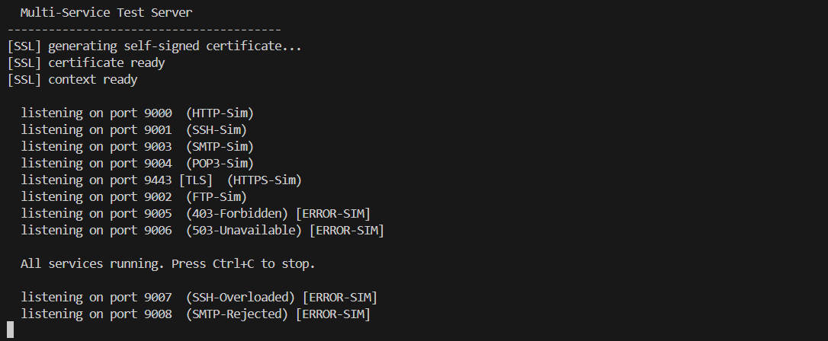
CLIENT:
